Urban Physics, 7S0X0

Urban Acoustics, Exercises week 7

- This exercise is the continuation of the exercise of week 6. Without the noise barrier, the noise level per 1/1 octave band L_{p,i} at 110 m from the highway, at a height of 4 m is shown in Table 1.

- There is a plan to construct an open car-parking space of 10 m width just in front of the residential area. Before it could be built, the planners want to check if the parking ground will lead to an increase in sound levels at the nearest façade; if it does increase, they plan to build the parking space on the other side. Compute the difference in A-weighted sound level L_{p,A} .
- For the receiver position at 110 m from the highway and 4 m height, compute the difference in A-weighted sound level L_{p,A} for favourable conditions. Make use of figure 1 for computing the ground effect and make use of A_{div} = 10log₁₀(d)+8, with d the direct distance between source and receiver.
- To reduce the noise level, a thin 4 m tall barrier was proposed at 10 m from the road. For homogeneous conditions, the values of L_{p,i} at the receiver point of a) per 1/1 octave band are shown in Table 1. For the same configuration, compute the difference in A-weighted sound level L_{p,A} for favourable conditions using figure 2.
- A barrier is also located at 10 m at the other side of the road, see figure 3. Draw the sound rays in figure 3 that determine the sound level at receiver position R due to source position S. Neglect multiple (more than 1) reflections from the noise barrier.
- Compute the A-weighted sound level L_{p,A} at the receiver position in the situation of figure 3, that means with the two barriers in homogeneous conditions. Assume the absorption coefficient α from the barrier is equal to 0. Make use of Figure 4.
- How much is L_{p,A} reduced when the faces of the barriers have an absorption coefficient α= 0.9 for all frequencies?

Table 1. Sound pressure level L_{p,i} at 110 m from the highway, at a height of 4.

f  (Hz) | L_{p,i} homogeneous, no barrier | L_{p,i}  homogeneous  barrier
 | (dB) | (dB)
63 | 56.6 | 49.8
125 | 57.2 | 48.1
250 | 56.8 | 45.3
500 | 58.0 | 43.8
1000 | 63.1 | 46.0
2000 | 54.2 | 40.2
4000 | 40.1 | 27.3

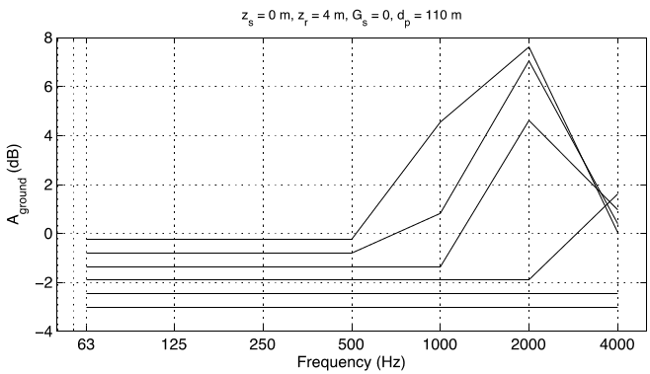
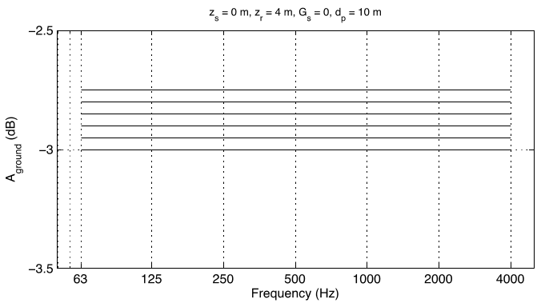
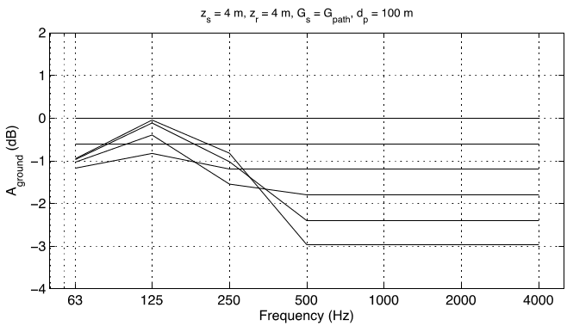
Figure 1. A_{ground} for various values of G’_{path} for favourable conditions. Lines for G’_{path} = 0 (lowermost line) to G’_{path} = 1 (upper line). Other lines with increment of G’_{path} = 0.2.
Figure 2. A_{ground} for various values of G’_{path} for favourable conditions. Lines for G’_{path} = 0 (lowermost line) to G’_{path} = 1 (upper line). Other lines with increment of G’_{path} = 0.2.


Figure 3. Schematic situation with two noise barriers. The source is located 10 m from each barrier, and the ground in-between the barriers is very hard and dense asphalt (G=0).
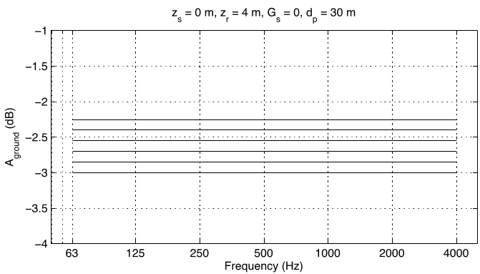

Figure 4. A_{ground} for various values of G’_{path}. Lines for G’_{path} = 0 (lowermost line) to G’_{path} = 1 (upper line). Other lines with increment of G’_{path} = 0.2.

